**ICE 4-1**

**Group Doc Link:** [Group Doc](https://docs.google.com/document/d/130SAgyYl7gk0stA_f2ERAp4yrEqYagD701-0N2kvyl8/edit?usp=sharing)

**Jamboard Link**: [Jamboard](https://jamboard.google.com/d/1fTD-BJ66ruQK3cfuL9QVu6qJ2wqDoJ1nBiQovXZSmx4/viewer)

**Product Vision**

**FOR**: Students who have just graduated from university

**WHO**: Are looking for employment opportunities

**THE**: Interview Insight is an web-based application

**THAT**: Provides users with efficient training to be able to present themselves better at an interview

**UNLIKE**: LinkedIn that only shows you the available list of recruiters and what they are looking for

**OUR PRODUCT**: Emphasizes on improving certain set of skills that would help a new-comer to be able to adjust to the business environment.

**Stakeholders**

Stakeholders for this project would involve UNC Charlotte (now Charlotte), College of Computing and Informatics (CCI), and other colleges that would like to implement this kinda system for recruitment.

**Links**

<https://www.indeed.com/career-advice/finding-a-job/can-not-find-a-job-after-college>

<https://www.cnbc.com/2021/04/15/what-college-graduates-can-do-about-being-out-of-work.html>

**Customer Discovery**

Some questions that could be asked are:

* If you don't have work experience, how can you improve your Resume and the recruiter to believe that you are well qualified for the job?
* How involved should you be in looking for a job? Even though you are a 3.8+ GPA student, how different is your process of job searching than any other student who hasn't performed that well.
* Do you think going back to school after graduation improves your process of job searching? Is double-graduation worth it?

**User Journey Map**

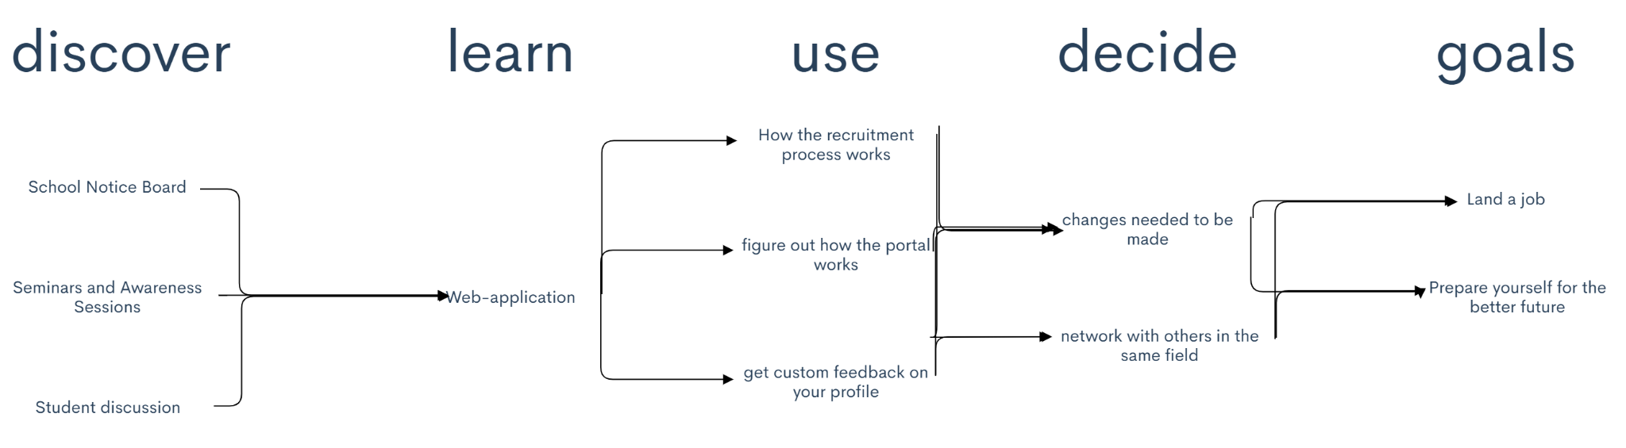

**HMW Notes**

* How might we make sure that the student is able to get the help they need?
* How might we make sure that the student is able to connect with recruiters and get appropriate feedback?
* How might we get the recruiters to work with the student and give them actual feedback that is suitable for that particular student?